**PLANT DISEASE DETECTION**

Submitted by

**Name Reg No**

AJITHA V 223007

ANAMIKA U 223012

MUHAMMED FARIS MUKTHAR M V 223037

In partial fulfilment of the requirements for the award of Master of

Science in Computer Science with Specialization in Data Analytics



Of

School of Digital Sciences

Kerala University of Digital Sciences, Innovation, and Technology

(Digital University Kerala)

Techno city Campus, Thiruvananthapuram, Kerala – 695317

December 2023

**BONAFIDE CERTIFICATE**

This is to certify that the project report entitled PLANT DISEASE DETECTION submitted by:

**Name Reg No**

AJITHA V 223007

ANAMIKA U 223012

MUHAMMED FARIS MUKTHAR M V 223037

in partial fulfilment of the requirements for the award of Master of Science in Computer Science with Specialization in Data Analytics is a Bonafide record of the work carried out at KERALA UNIVERSITY OF DIGITAL SCIENCES, INNOVATION AND TECHNOLOGY under our supervision.

Supervisor Course Coordinator

Prof. MANOJ KUMAR T K Prof. MANOJ KUMAR T K

School Of Digital Sciences School of Digital Sciences

DUK DUK

Head of Institution

Prof. SAJI GOPINATH

Vice Chancellor

DUK

**DECLARATION**

We, Ajitha V, Anamika U and Muhammed Faris Mukthar M V, students of Master of Science in Computer Science with Specialization in Data Analytics, hereby declare that this report is substantially the result of our own work, and has been carried out during the period March 2023-July 2023.

Place: TRIVANDRUM

Date: 02/01/2024

**ACKNOWLEDGEMENT**

We want to convey our sincere and deepest gratitude to our mentor Dr. Manoj Kumar T K, Associate Professor, Digital University Kerala, Trivandrum, for his invaluable assistance, counsel, and support, all of which helped me to successfully complete my project.

We would also like to express our sincere gratitude to Prof. Saji Gopinath for giving us the favourable conditions, insightful advice, and educational resources that improved our capacity to carry out a project of this magnitude.

We would also like to take this chance to express our gratitude to our families and friends for their invaluable help, inspiration, and support throughout the completion of this project.

**ABSTRACT**

This study uses YOLOv8, an enhanced version of the YOLO object detection model, to provide a unique method for predicting tomato leaf disease. The model is trained on a large dataset that includes photos of both healthy and diseased tomato leaves, including those with Early Blight, Late Blight, Leaf Miner, Leaf Mould, Mosaic Virus, Septoria, Spider Mites, and Yellow Leaf Curl Virus. By utilising deep learning techniques, the suggested method correctly categorises the leaves of tomato plants as either healthy or unhealthy, and if a disease is present, it also pinpoints the exact ailment. The algorithm achieves great accuracy in disease diagnosis and real-time prediction capabilities by examining the unique visual characteristics linked to each disease. This makes it easier to implement management plans and timely interventions, giving farmers the ability to minimise the spread of disease and maximise crop health and output. The suggested strategy is a major development in agricultural technology and provides a workable way to increase crop productivity and food security in a sustainable manner.

**CONTENTS**

**Introduction7**

**Materials and Methods8**

Libraries8

Dataset9

YOLOv810

**Results and Discussions12**

**Conclusion15**

**Bibliography16**

**INTRODUCTION**

Deep learning methods have produced encouraging results in a number of industries, including agriculture, in recent years. In this work, we present an innovative method for predicting tomato leaf disease using the You Only Look Once (YOLO) object detection model's upgraded version, YOLOv8. The goal is to precisely categorise tomato plant leaves as healthy or diseased, and if a disease is present, to further identify the particular disease. The dataset used to train the suggested model includes photos of both healthy and diseased tomato leaves, including those with Early Blight, Late Blight, Leaf Miner, Leaf Mould, Mosaic Virus, Septoria, Spider Mites, and Yellow Leaf Curl Virus.

Within the input leaf photos, the model is trained to identify and categorise regions of interest. The algorithm learns to distinguish between healthy and damaged leaves by examining the unique visual characteristics linked to each condition. After drawing conclusions, the model determines if the input leaf is healthy or unwell and, if it is, it pinpoints the precise ailment that is harming the plant.

The suggested method has a number of benefits, such as the capacity to handle various disease classes at once, precise disease detection, and real-time prediction capabilities. Additionally, the model achieves a balance between speed and accuracy by utilising the YOLOv8 architecture, which qualifies it for practical deployment in agricultural contexts. The suggested method is effective in properly diagnosing tomato leaf diseases, as demonstrated by the experimental findings. This allows for timely intervention and management measures to ensure crop health and yield.

**MATERIALS AND METHODS**

**2.1 Libraries**

1. Roboflow

Roboflow is a computer vision platform that provides better ways to acquire data, preprocess it, and train models, allowing users to create models more quickly. For computer vision researchers and developers looking to optimise the complex process of preprocessing and managing datasets, it is a very helpful tool. Roboflow is primarily intended to handle the difficult chore of managing and preparing datasets for machine learning models. One of its best features is how simple it is to integrate with popular computer vision frameworks like TensorFlow, PyTorch, and YOLO.

In the rapidly evolving field of computer vision, this integration fosters creativity and adaptability by providing users with a range of model architectures and frameworks to work with. Preprocessing and data augmentation are essential steps in increasing the diversity and quality of datasets, which has a direct impact on how well machine learning models perform. In these areas, Roboflow shines, offering a wide range of augmentation techniques to enhance datasets. Users may apply transformations, resize photographs, and carry out other preprocessing tasks with ease thanks to the platform's user-friendly interface, which helps to expedite the data preparation workflow. One of the best examples of efficiency in the challenging subject of computer vision is Roboflow. Because of its integration capabilities, dataset management tools, and commitment to data quality through augmentation and pretreatment, it is a highly recommended choice for academics and developers. Roboflow is still a trusted partner, helping users navigate the challenges of dataset preparation with ease and confidence as technology advances and machine learning applications grow more intricate.

1. Ultralytics

Ultralytics is a flexible computer vision toolkit that works with well-known frameworks such as TensorFlow and PyTorch. With an intuitive interface, it streamlines the process of developing and training models and accommodates a range of model designs to meet the needs of different project types. YOLOv8 Ultralytics: A sophisticated object detection model, which is well-known for its excellent accuracy and real-time efficiency, is a crucial part of the Ultralytics toolbox. YOLOv8, which seamlessly integrates with the Ultralytics ecosystem, is notable for its adaptability to a variety of object identification tasks in industries like industrial automation, autonomous cars, and surveillance. With components like the CSPDarknet53 backbone and PANet for better feature extraction, the model's expanded architecture contributes to its increased accuracy and robustness.

YOLOv8 uses distributed training and mixed-precision training, taking advantage of the optimisation techniques in the Ultralytics toolbox. This allows for faster training convergence and effective resource use, even for large datasets. Its effectiveness in recognising objects across multiple domains is demonstrated by its success in real-world applications. While keeping a user-friendly interface, YOLOv8 upholds Ultralytics' dedication to simplicity without sacrificing the model's depth for intricate machine vision applications.

Because of its adaptability and user-friendliness, the model is continuously improved thanks to its active participation in the Ultralytics community. To sum up, Ultralytics YOLOv8 is a big advancement in object identification models and gives researchers and developers a strong tool to deal with a variety of difficult real-world situations.

**2.2 Dataset**

The dataset consists of 10746 images of tomato leaves. The images are of healthy leaves and leaves with diseases like Early Blight, Late Blight, Leaf Miner, Leaf Mold, Mosaic Virus, Septoria, Spider Mites and Yellow Leaf Curl Virus. The dataset is further split into train, test and valid sets. The train set consists of 9801 images, valid set of 783 images and test set of 162 images. The dataset was taken from Roboflow universe.

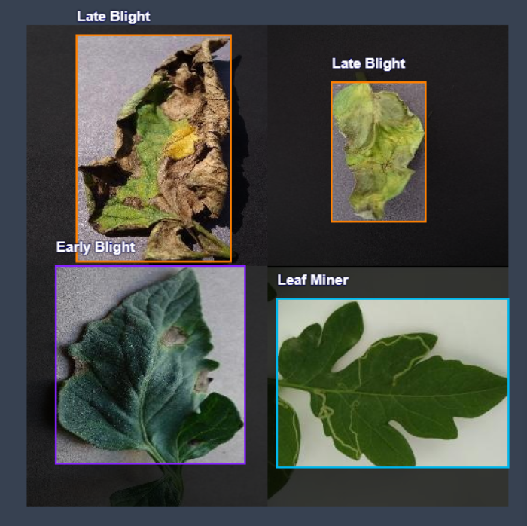

Figure 1: Sample images from the dataset.

**2.3 YOLOv8(You Only Look Once)**

With remarkable speed and accuracy, YOLOv8 is a real-time object identification and picture segmentation model built on the latest developments in deep learning and computer vision. Because of its straightforward architecture, it may be readily scaled to a number of hardware platforms, including edge devices and cloud APIs, and is suitable for a broad range of applications.

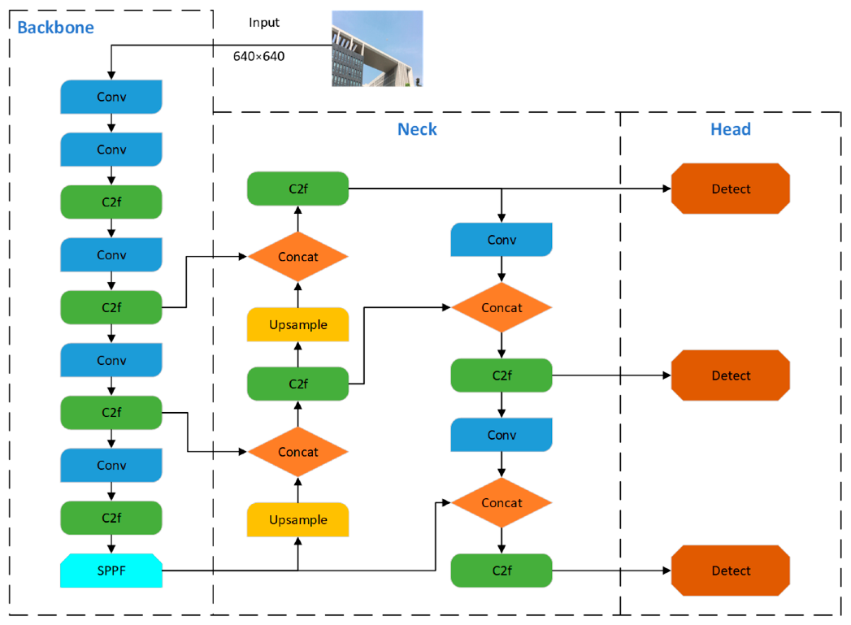

Figure 2:A diagrammatic representation of YOLOv8 architecture.

YOLOv8 employs an anchor-free model with a detached head to perform objectness, classification, and regression tasks independently. By allowing each branch to concentrate on its own role, this architecture enhances the overall accuracy of the model. In the YOLOv8 output layer, the activation function for the objectness score was the sigmoid function, which expressed the likelihood that the bounding box contains an object. It represents the odds of objects belonging to each possible class using the softmax function. YOLOv8 employs binary cross-entropy for classification loss and CIoU [68] and DFL [108] for bounding box loss. Performance for object detection has improved as a result of these losses, particularly for small objects. The backbone is a CSPDarknet53 feature extractor, which is followed by a C2f module, as opposed to the conventional YOLO neck architecture. Two segmentation heads that are trained to predict the semantic segmentation masks for the input image come after the C2f module. With five detection modules and a prediction layer, the model's detection heads are comparable to those of YOLOv8. While still being quick and effective, the YOLOv8-Seg model has demonstrated state-of-the-art performance on numerous object identification and semantic segmentation tasks.

**RESULTS AND DISCUSSIONS**

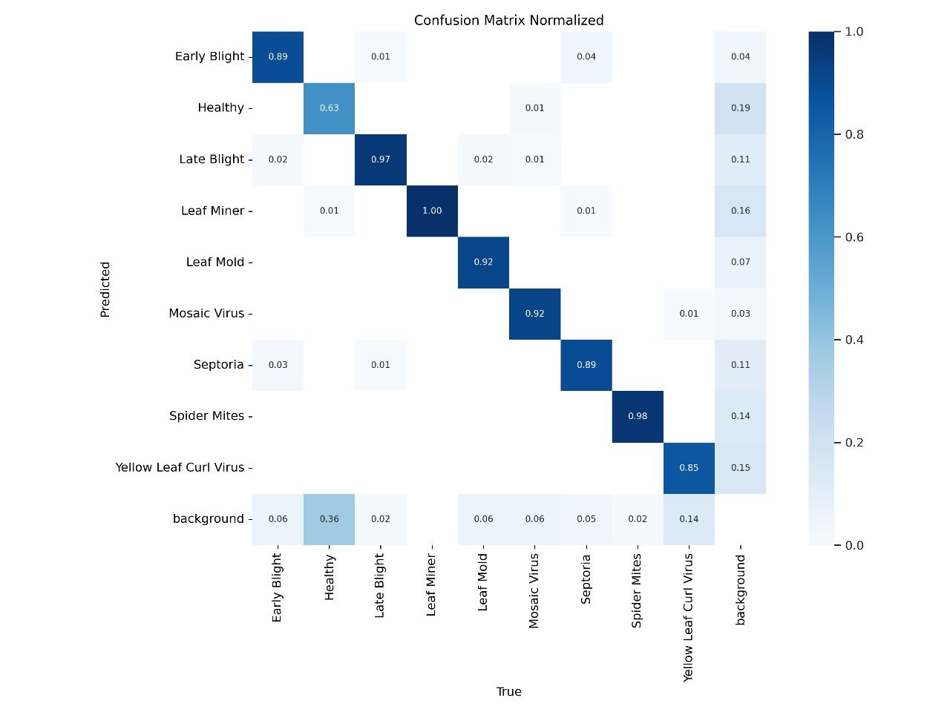

Figure 3:Confusion matrix of the model.

The above figure illustrates the confusion matrix of leaf disease detection model. Predicted classes are on vertical axis, and the true classes on the horizontal axis. The number of accurate predictions is displayed in the matrix's diagonal cells, while the number of inaccurate predictions is displayed in the off-diagonal cells. With precision accuracy scores of 1.00 and 0.98 for Leaf Miner and Spider Mite diseases, respectively, the model does remarkably well in these areas. With accuracy scores of 0.89 and 0.97 for Early Blight and Late Blight, respectively, it indicates a significantly poorer accuracy. Notably, there is a 2% misclassification rate between Early Blight and Late Blight, and approximately 6% of healthy plants are mistakenly identified as infected. In conclusion, although the model performs exceptionally well in identifying specific diseases, it occasionally misclassifies healthy plants and confuses diseases that are similar.

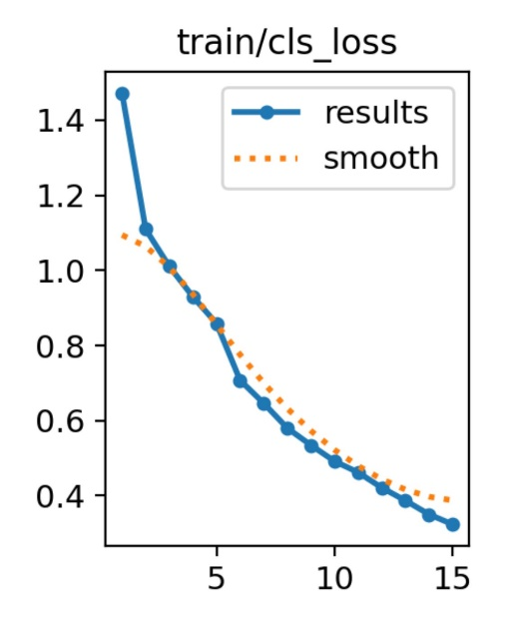 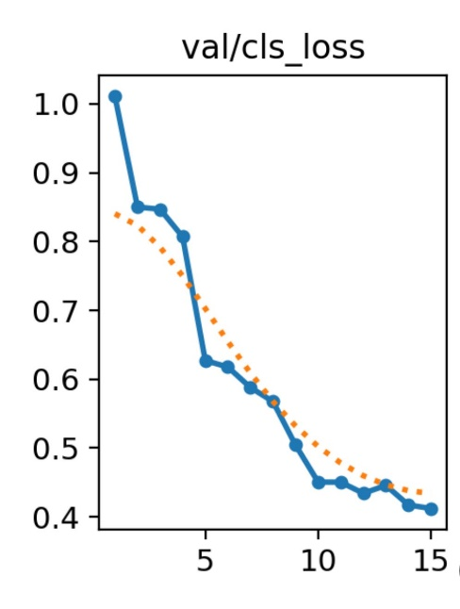

Figure 4: Training and Validation loss plots

The number of epochs, or iterations over the training data, is displayed on the x-axis. The training loss, a gauge of the model's effectiveness using the training set, is displayed on the y-axis. The training loss is represented by the blue line, and the smooth loss—a moving average of the training loss—is represented by the orange line. The model is improving its ability to recognise tomato leaf diseases, as seen by the graph's decreased training loss over time. Although it is less volatile than the training loss, the smooth loss is likewise declining. This is because the training loss's oscillations are lessened by the smooth loss, which is a moving average.

Due to the smoothing effect, it often has a less volatile decrease trend than training loss. The validation loss varies from about 1.2 to about 0.5, suggesting that the model performs well when applied to new data. The model appears to have trained well without overfitting to the training set based on the notable decrease in both training and validation loss. At the end of training, the validation loss begins to plateau while the training loss still marginally decreases, indicating that additional training may not be very beneficial.

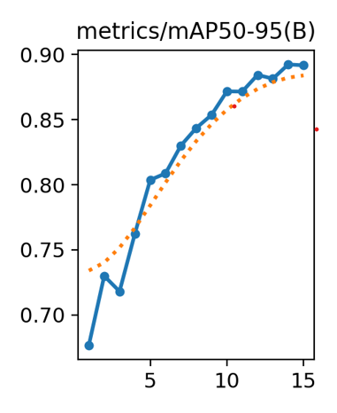

Figure 5: mAP plot of the model.

Models for object detection are assessed using a statistic called Mean Average Precision (mAP). It takes into account both false positives and false negatives, as well as the trade-off between precision and recall. Because of this feature, mAP is a useful statistic for the majority of detection applications. The figure above shows the progression of mAP, it has been a quite consistent rise. An approximate mAP value of 89% is achieved by the model.

**CONCLUSION**

This study uses the YOLOv8 object detection model to propose a novel method for tomato leaf disease identification. After being trained on a diverse dataset that included pictures of both healthy and diseased leaves, the model is able to discriminate between various states of health. While some diseases, like Leaf Miner and Spider Mites, can be accurately detected with great precision, other diseases, like Early Blight and Late Blight, have varying degrees of accuracy. Interestingly, the model shows a steady increase in Mean Average Precision (mAP) to about 89%, which suggests a general performance improvement. Nonetheless, there are still issues, such as incorrectly labelling healthy plants as diseased and misclassifying diseases that are similar to one another. However, this approach has potential for managing crop health; hence, more development is needed to improve precision and dependability in farming settings.

**BIBLIOGRAPHY**

YOLO (You Only Look Once) Pre-trained model Documentation. <https://docs.ultralytics.com/modes/track/>

Mohanty SP, Hughes DP and Salathé M (2016) Using Deep Learning for Image-Based Plant Disease Detection. *Front. Plant Sci.* 7:1419. doi: 10.3389/fpls.2016.01419

Morbekar, A. Parihar and R. Jadhav, "Crop Disease Detection Using YOLO," 2020 International Conference for Emerging Technology (INCET), Belgaum, India, 2020, pp. 1-5, doi: 10.1109/INCET49848.2020.9153986. keywords: {Diseases;Agriculture;Object detection;Training;Production;Machine learning;Feature extraction;Object detection;Neural network;Augmentation;Diseased crops;Grid cells}

C. L. K R, P. B, S. G, N. J. J, G. T and M. Hashim, "Yolo for Detecting Plant Diseases," 2023 Third International Conference on Artificial Intelligence and Smart Energy (ICAIS), Coimbatore, India, 2023, pp. 1029-1034, doi: 10.1109/ICAIS56108.2023.10073875. keywords: {Plant diseases;Analytical models;Pathology;Neural networks;Crops;Object detection;Machine learning;Plant Disease;You Only Look Once (YOLO V3);Object detection;Grid Cell}